The Tool That Got Away

Disclaimer: This case study was prepared by Cody Galez and Kevin Neo under the supervision of Dr. Frances Tuer, DeGroote School of Business, solely for the purpose of discussion. While the injury in the case actually took place all details of person(s) and organization(s) have been disguised.

The Injury/ Illness:
It was a typical Wednesday morning during summer break at the Grant Construction Company as Ben Corolla and the rest of the crew met at the office around 7 a.m. ready to build another client a pool in their backyard. The Grant Construction Company had a firm deadline to finish building the pool by the end of day Friday. The crew was quite behind schedule and this resulted in them trying to pick up the work pace that morning to fulfill their objective for the end of the week. Ben’s task was to put up a temporary fence around the pool for public safety and prevention of falling into the deep hole in the ground.
Part of the process involved pounding posts for the fence, something that Ben had done regularly and was competent at. While hurrying to finish a section so he could go for lunch, he had accidentally lifted the post pounder too high above his head, smashing it into the top of his head and cutting it open, as well as feeling dazed and disoriented. As he dropped the post pounder, he staggered away to the worksite office to inform his manager what happened.

Who and What:
Ben Corolla was heading into his fourth, and final, year of studies in university. During his summer months, when school was finished for the year, he worked with a private company, Grant Construction. Ben began his employment at the conclusion of his first year at university, working 40 hours from Monday-Friday during the summer, as well as part-time on weekends in the fall to pay for his rent and tuition.
Grant Construction Company is a construction company that specializes in building pools for private clients. Their workforce is primarily comprised of middle-aged men with little education credentials, as well as university and college students in summer months due to the regular spike in demand during these months. There is little organizational stress for training and personal protective equipment (PPE), as most employees have a flippant attitude towards their manual-labour jobs, and only care about meeting client deadlines to avoid working overtime on weekends.
The process of putting up the temporary fence involved placing T-bars (see Exhibit 1) around the perimeter of the pool and using a post pounder tool (see Exhibit 2) to hit them firmly in the ground. This is something he had done many times throughout the years he has been with the Grant Construction Company. As a result of his experience with the company, his manager had no reason to doubt his ability to work independently, as Ben had been an exemplary worker thus far.

Background on this type of injury:
According to the Ontario Ministry of Health and Long-Term Care (MOHLTC), a concussion is a brain injury causing changes in brain function and can occur from a blow to the head or body, causing the brain to move rapidly back and forth within the skull (MOHLTC, 2018). Common symptoms include headaches, dizziness, difficulty concentrating or remembering, depression or irritability, and drowsiness or difficulty falling asleep (Ontario Ministry of Health and Long-Term Care, 2018). Concussions can result in permanent or severe brain damage if not identified and properly managed (Ontario Ministry of Health and Long-Term Care, 2018).
According to the Canadian Centre for Occupational Health and Safety (CCHOS), concussions are most common in transportation, storage, government, and primary (forestry, fishing, mining, etc.) industries, with the main causes being falls, being stuck with or striking an object, and vehicle collisions although main causes vary by industry and occupation (CCHOS, 2017). Common prevention tactics include keeping work spaces clear of clutter, cords, and puddles to prevent tripping, keep shelf space organized to prevent falling objects, proper footwear in order to prevent slippage, and use of well-fitting hard hats (CCHOS, 2017).
The Association of Workers’ Compensation Boards of Canada (AWCBC) reported that 25,514 lost time claims were filed by construction workers in Canada in 2016, and 24,607 lost time claims in Canada in that year were due to some type of head injury (AWCBC, n.d.). In 2014, approximately 240,000 people suffered an injury serious enough to warrant missing time from work (lost-time injury) (Kelloway, Francis & Gatien, 2017). The construction sector alone had 11% of the total number of lost-time injuries in 2014 when looking at all sectors in Ontario, which is higher than the sector’s share of WSIB-covered employment (9%), overall employment (7%) and the province’s gross domestic product (6%) (Ontario Ministry of Labour, 2016).
What to do next?
After his manager inspected and cleaned the wound, it was clear Ben would need to go get stitches. His manager then advised a co-worker to take Ben to the nearest walk-in clinic where he received three stitches in his head and was formally diagnosed with a minor concussion from the impact to his head. Following their visit to the walk-in clinic, Ben and his co-worker returned to work to continue building the pool for their client in order to meet the promised deadline.
The next day, Ben Corolla’s manager told him to take the rest of the week off to rest and heal from the injuries sustained. Ben Corolla contemplated whether it was a good idea for him to return to work the previous day following the stitches he received and concussion diagnosis. He also had yet to go through any formal process of reporting the injury, as he should have. Ben feared he may lose his much-needed job, as he needed money to pay for rent and tuition for the upcoming school year. Since he had been with the company for three years, Ben felt loyal to his manager, as well as the company, and did not want to attract negative attention to them by reporting the incident. Ben also felt this would not happen again because he would make sure to be more careful the next time he handled the post-pounder tool – although he was aware that this kind of injury had happened to co-workers in the past as well in a similar manner. The question came down to: should he file an official report for his injury and risk his employment status? Or continue working as normal when the week ended?

Exhibit 1 – T-bar for Fencing:
https://www.lowes.com/pd/Actual-1-4-in-x-3-in-x-6-ft-Green-Steel-Farm-Fence-T-Post/4758566

Exhibit 2 – Post Pounder Tool:

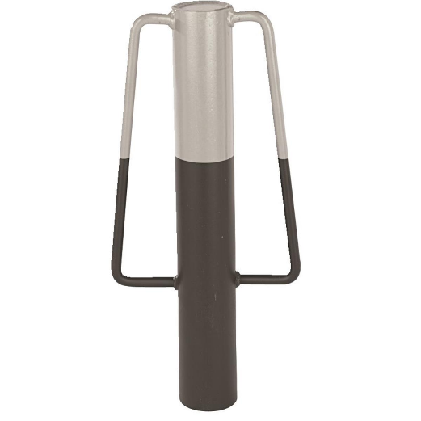
https://www.gemplers.com/product/139248/Steel-Post-Pounder-3-1-2-dia

